**How to use ShowCoreTeamMembersDataGeneration.sql, Update version for a project and a associate for Revised data.sql and Update version for a project and an associate for To Completed data.sql**

Sometimes, when trying to move Revised or Reforecast data from one associate to another, one gets the message “There is no data to transfer”.

Most likely the reason is that the associate who leaves doesn’t have data with last IdGeneration.   
In order to see if this is the case, one can run “ShowCoreTeamMembersDataGeneration.sql”

First, “ShowCoreTeamMembersDataGeneration.sql” should be open with an text editor and fill in project code in the line set @ProjectCode = ''   
Then one can run the script and gets a result like in the below picture.

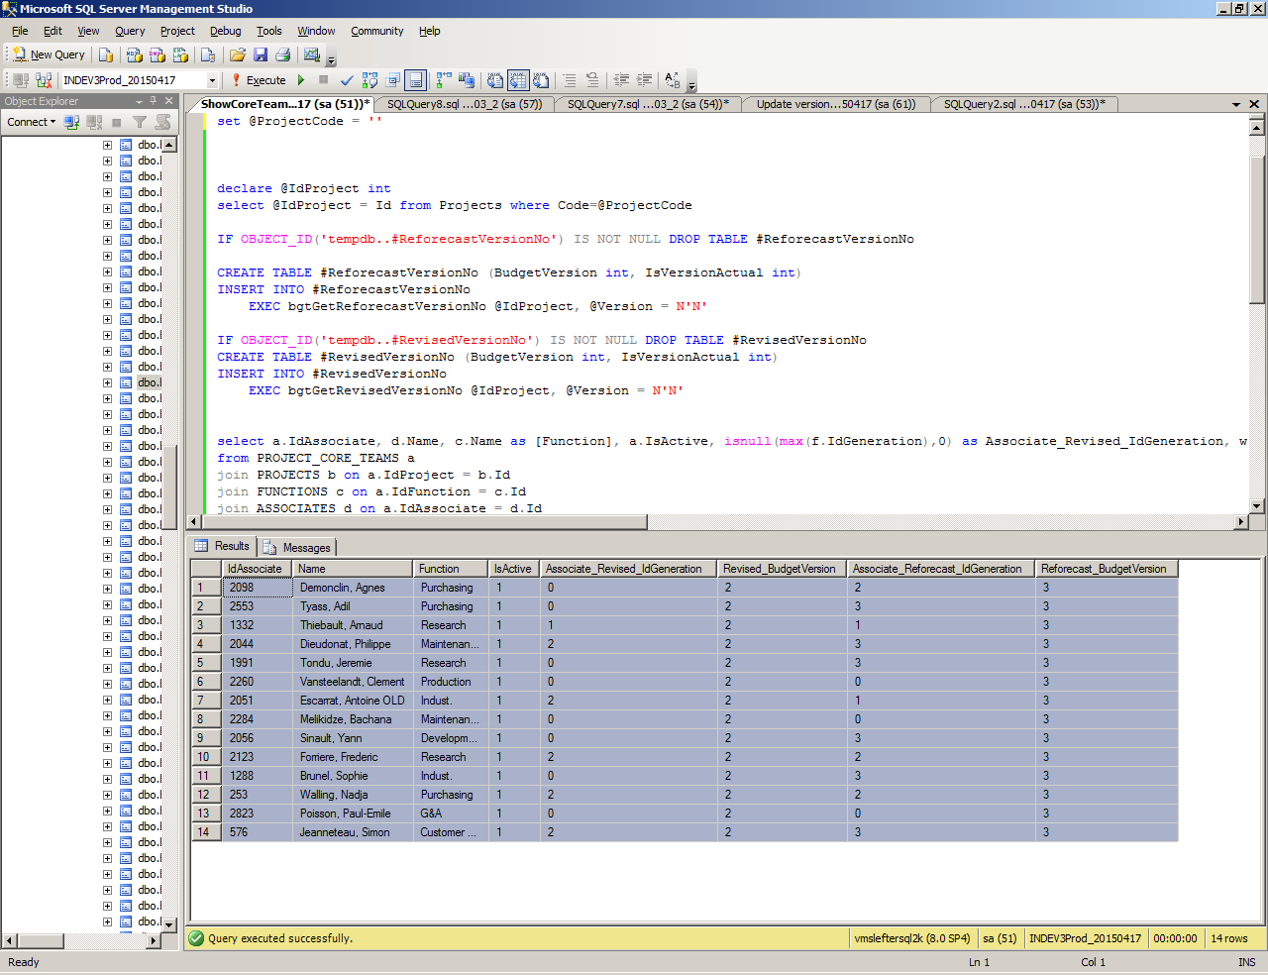

If Associate_Revised_IdGeneration is less than Revised_BudgetVersion or Associate_Reforecast_IdGeneration is less than Reforecast_BudgetVersion, then it should be run either “Update version for a project and a associate for Revised data.sql” or “Update version for a project and an associate for To Completed data.sql”, depending on what Transfer has to be completed (Revised or Reforecast).

From the results displayed above, one has to keep in mind IdAssociate for the associate who leaves.

Then one has to open “Update version for a project and a associate for Revised data.sql” or “Update version for a project and an associate for To Completed data.sql” and fill in IdAssociate and ProjectCode in the lines. Actually 0 is replaced with IdAssociate and project code must be put between apostrophes .

set @IdAssociate = 0

set @ProjectCode = ''

Then the script must be run. If it runs successfully it will display a message like “Operation completed”. Then the data transfer must be initiated again using the site.